
INTERNATIONAL INDIAN SCHOOL, TABUK
TERM- 1 (SESSION: 2025-26)
PRACTICE SHEET 2
CLASS: I SUBJECT: ENGLISH TOPIC: THE RAINBOW+WORKSHEET 2
LUNA STAYS AWAKE+ WORKSHEET 3
1 | Answer the following questions.  a)What makes the pitter-patter sound?  ____________________________________________  b)Do you think the speaker feels happy when she sees a rainbow?  _____________________________________________  c)Who is Luna?  _____________________________________________  d)What does the bird do?  _____________________________________________  e)What happens before it rains?  _____________________________________________
2 | Add capital letters and full stops to these sentences.  a)it is a hot day  ________________________________  b)the crow sits on the branch of a tree  _____________________________  c)we are in ooty  ________________________________  d)ahmed is going to delhi  ________________________________  e)kala has many friends  __________________________________
3 | Look at these words . Write the two words in the blanks.  a)cupboard =__________+__________  b)sunflower =_________+__________  c)rainbow = _________+__________
4 | Complete these sentences using the words in the box.  (He She It They)  a)Renu reads a book.  _______ reads a book.  b)Where is my bag?  _______ is on the floor.  c)Where are the pencils?  _______are in the box.
5 | Write the plurals of these words using s or es.  a)Bush ________  b)Torch ________  c)Crayon ________  d)Mango ________
6 | Use these words to make compound words that match the pictures.  (fly fish ball ring)  a)foot + ________= 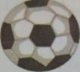 ________  b)butter+________= 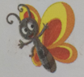 ________  c)ear +________= 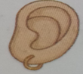 ________  d)gold +________= 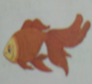 ________
7 | Choose the correct words from the box to complete these sentences.  ( Neck Finger Head)  a)You wear cap on your ________ 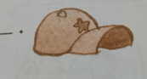  b)You wear chain around your________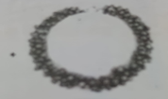  c)You wear ring on your __________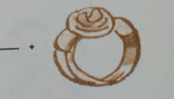
8 | Match the words with the correct pictures.  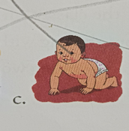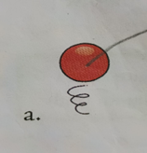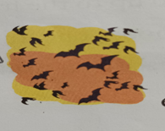  Fly crawl bounce

